**Question 1:**

**WAP to enter any two number and swap them without using third variable**

#include<stdio.h>

void main()

{

int a,b;

printf("Enter the values for a: ");

scanf("%d",&a);

printf("Enter the value for b: ");

scanf("%d",&b);

a=a+b;

b=a-b;

a=a-b;

printf("\nAfter swaping a=%d",a);

printf("\nAfter swaping b=%d",b);

}

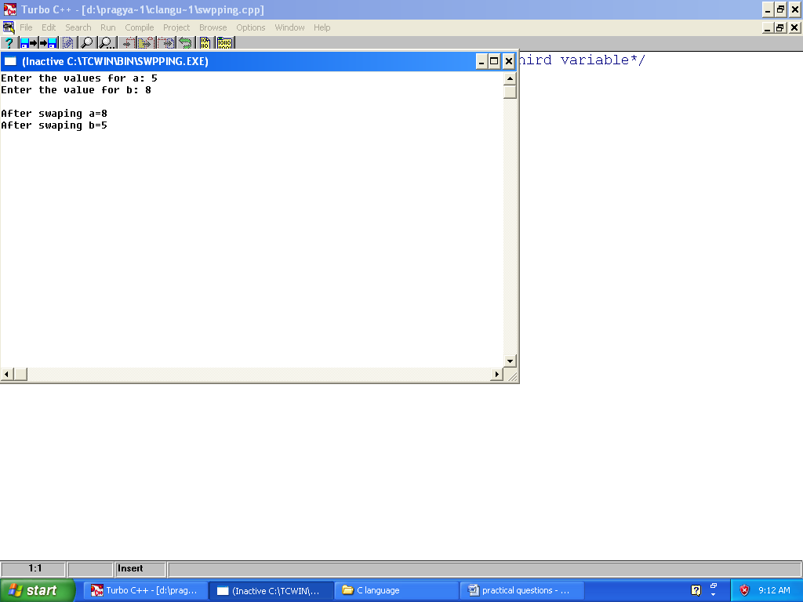

Question-2

/*WAP to display exponential series*/

#include<stdio.h>

#include<conio.h>

void main()

{

int n,a,b,power=1,sum=0,x;

clrscr();

printf("Enter the value of x:");

scanf("%d",&x);

printf("Enter the terms:");

scanf("%d",&n);

for(a=1;a<=n;a++)

{

printf("%d^%d",x,a);

if(a<n)

{

printf("+");

}

else

{

printf("+=");

}

power=1;

for(b=1;b<=a;b++)

{

power=power*x;

}

sum+=power;

}

printf("%d",sum);

getch();

}

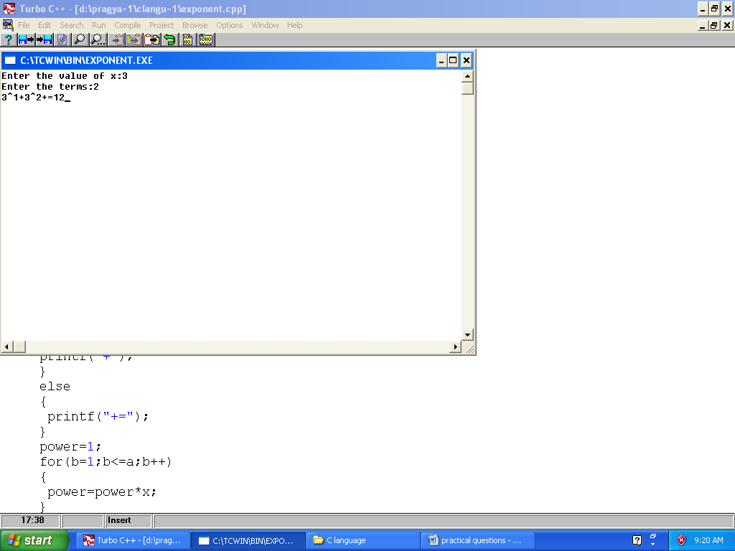

QUESTION-3

/*WAP to find out fibbannocci series */

#include<stdio.h>

void main()

{

int n,i,a,b,c;

a=0,b=1;

printf("Enter the range:");

scanf("%d",&n);

printf("%d",a);

printf("%d",b);

i=2;

while(i<n)

{

c=a+b;

printf("%d",c);

a=b;

b=c;

i=i+1;

}

}

Output:

QUESTION-4

/*Greatest value among 4 no.*/

#include<stdio.h>

#include<conio.h>

void main()

{

int a,b,c,d;

clrscr();

printf("Enter any four no:");

scanf("%d%d%d%d",&a,&b,&c,&d);

if(a>b&&a>c&&a>d)

{

printf("First value is greater=%d",a);

}

else if(b>a&&b>c&&b>d)

{

printf("Second value is greater=%d",b);

}

else if(c>a&&c>b&&c>d)

{

printf("Third value is greater=%d",c);

}

else

{

printf("Fourth is greater=%d",d);

}

getch();

}

